Create a vm and enable http/https for that

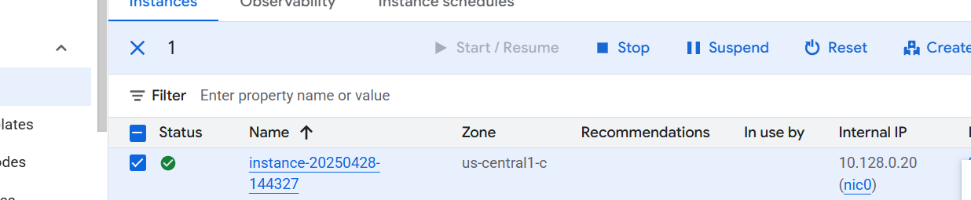

Create instance group from that vm

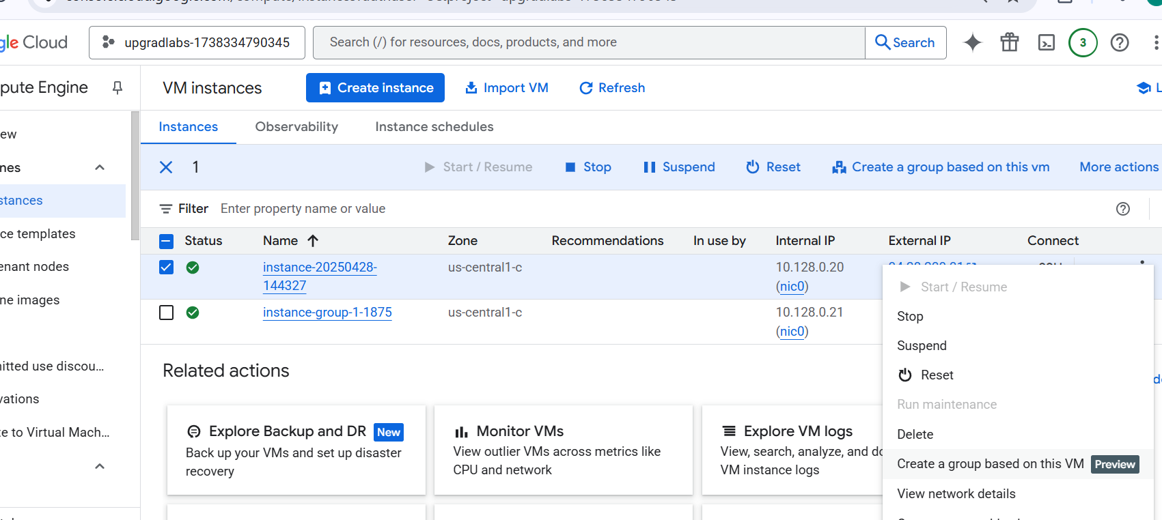

Check the instance group

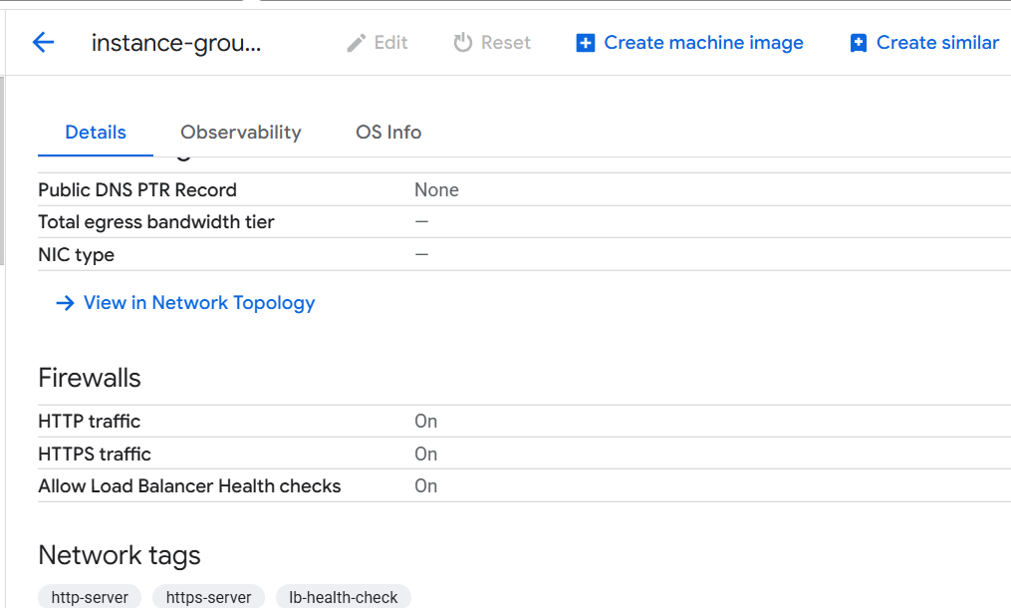

Now map this instance group in your LB, it will work